## ECO 5375 – 701 T. Fomby

Economic and Business Forecasting Fall 2021

Visakh Madathil - 46065231

# EXERCISE 1

**Purpose**: To get some practice in running programs on R, SAS, and EVIEWS. This exercise is due on **Thursday, September 2 by 6:30 PM on Canvas**.

Go to the Canvas homepage for “Week 1” and download the following programs: FPP_2.2 TS Plots.R, Plano_Plot.sas, and plano_plot.wf1. You will need to download R and RStudio to your personal computer to run the R program and the software package Citrix Receiver to be able to run the SAS and EVIEWS programs. Using these programs complete the following tasks:

(a) Report the plot of the Sydney-Melbourne Economy Class passenger data using the FPP_2.2 TS Plots.R program.

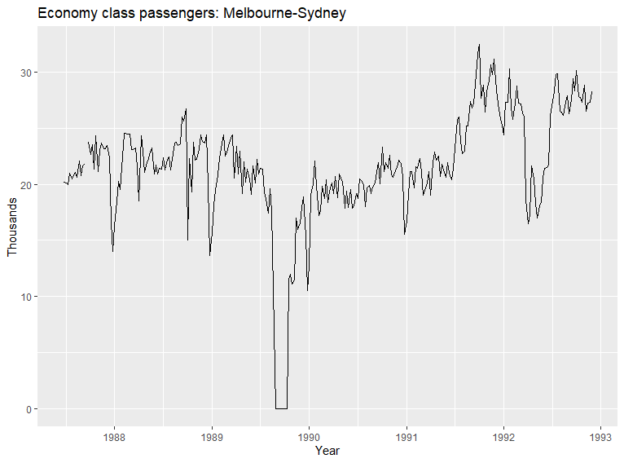

(b) Report the plot of the Plano Sales Tax Revenue data using the Plano_Plot.sas program.

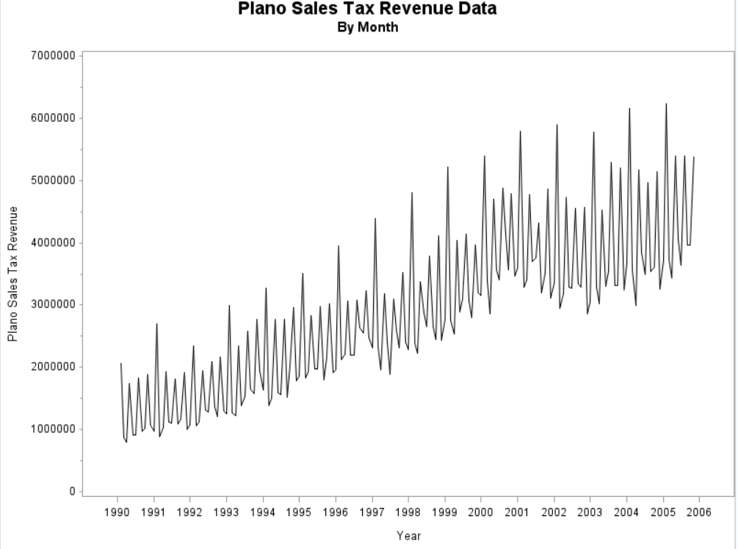

(c) Report the plot of the Plano Sales Tax Revenue data using the plano_plot.wf1 program.

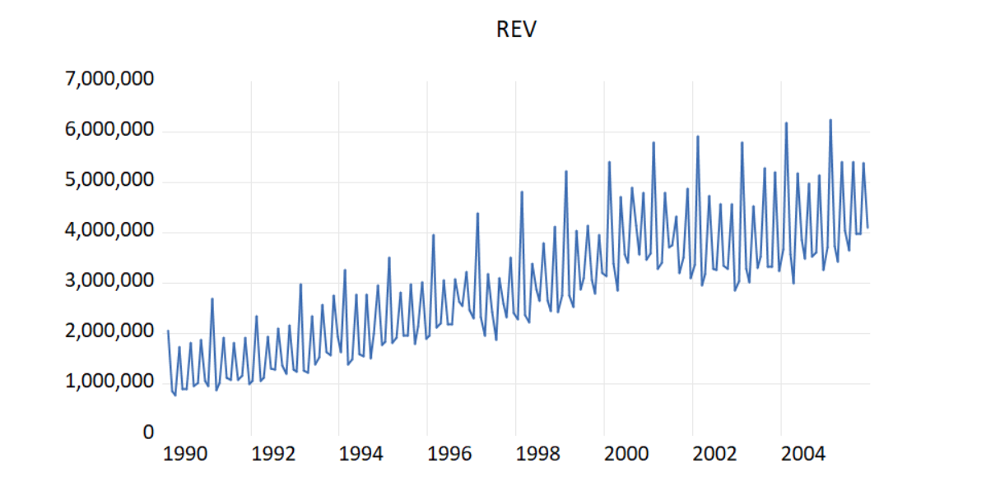

Submit your file in the “Assignments” area of Canvas.